**SKIN DISEASE IDENTIFICATION USING IMAGE ANALYSIS**

A UG Project Phase – I report submitted to

**JAWAHARLAL NEHRU TECHNOLOGICAL UNIVERSITY, HYDERABAD**

In partial fulfillment of the requirements for the award of the degree of

**BACHELOR OF TECHNOLOGY**

In

**COMPUTER SCIENCE AND ENGINEERING**

Submitted By

**THOUTI REDDY SUDEEPA 18UK1A05M4**

Under the guidance of

**Mr. A. ASHOK KUMAR**

Assistant Professor



**DEPARTMENT OF COMPUTER SCIENCE AND ENGINEERING**

**VAAGDEVI ENGINEERING COLLEGE**

Affiliated to JNTUH, HYDERABAD

BOLLIKUNTA, WARANGAL (T.S) – 506005

**DEPARTMENT OF COMPUTER SCIENCE AND ENGINEERING**

**VAAGDEVI ENGINEERING COLLEGE**

**WARANGAL**



**CERTIFICATE OF COMPLETION**

**UG PROJECT PHASE-1**

This is to certify that the UG Project Phase – I report entitled **"SKIN DISEASE IDENTIFICATION USING IMAGE ANALYSIS”** is being submitted by **T. SUDEEPA REDDY (18UK1A05M4)** in partial fulfillment of the requirements for the award of the degree of Bachelor of Technology in Computer Science & Engineering to Jawaharlal Nehru Technological University Hyderabad during the academic year 2021- 2022.

**Project Guide HOD**

**Mr. A. ASHOK KUMAR Dr. R. NAVEEN KUMAR**

(Assistant Professor) (Professor)

**EXTERNAL**



**ACKNOWLEDGEMENT**

We wish to take this opportunity to express our sincere gratitude and deep sense of respect to our beloved **Dr. P. Prasad Rao**, Principal, Vaagdevi Engineering College for making us available all the required assistance and for his support and inspiration to carry out this UG Project Phase – I in the institute.

We extend our heartfelt thanks to **Dr. R. Naveen Kumar**, Head of the Department of CSE, Vaagdevi Engineering College for providing us necessary infrastructure and thereby giving us freedom to carry out the UG Project Phase – I.

We express heartfelt thanks to the Major Project Coordinator, **Dr. J. Aruna kranthi**, Assistant Professor, Department of CSE for his constant support and giving necessary guidance for completion of this UG Project Phase – I.

We express heartfelt thanks to the guide, **Mr. A. Ashok Kumar**, Assistant Professor, Department of CSE for his constant support and giving necessary guidance for completion of this UG Project Phase – I.

Finally, we express our sincere thanks and gratitude to our family members, friends for their encouragement and outpouring their knowledge and experiencing throughout thesis.

**ABSTRACT**

Dermatology is the branch of bioscience that's involved with diagnosing and treatment of skin based mostly disorders. The immense spectrum of dermatologic disorders varies geographically and additionally seasonally because of temperature, humidness and alternative environmental factors. Human skin is one amongst the foremost unpredictable and tough terrains to mechanically synthesize and analyse because of its quality of unevenness, tone, presence of hair and alternative mitigating options. Though, many researches are conducted to find and model human skin victimisation (PC Vision techniques), only a few have targeted the medical paradigm of the matter. Due to lack of medical facilities available in the remote areas, patients usually ignore early symptoms which may worsen the situation as time progresses. Hence, there is a rising need for automatic skin disease detection system with high accuracy. Thus, we develop a multiclass deep learning model to identify the type of skin disease suffering from and Classifying the type of Skin Diseases into its main classes like Acne, Melanoma, Psoriasis, Rosacea, Vitiligo. We have used Deep Learning to train our model, Deep Learning is a part of Machine Learning in which unlike Machine Learning it uses large dataset and hence the number of classifiers is reduced substantially. The machine learns itself and divides the data provided into the levels of prediction and in a very short period of time gives the accurate results, thereby promoting and supporting development of Dermatology. The algorithm that we have used is Convolutional Neural Network (CNN) as it is one of the most preferred algorithm for image classification.

***Keywords – Dermatology, Dermatologic disorders,*** ***Acne, Melanoma, Psoriasis, Rosacea, Vitiligo, Machine learning, Deep Learning,, Convolutional Neural Network(CNN).***

**TABLE OF CONTENTS**

**LIST OF FIGURES**

**LIST OF CHAPTERS PAGE NO**

### INTRODUCTION 1

### MOTIVATION 1

### DEFINITION 2

### OBJECTIVE OF PROJECT 4

### PURPOSE 4

### PROBLEM STATEMENT 5

### LITERATURE SURVEY 6

### EXISTING SYSTEM 6

### PROPOSED SOLUTION 7

### EXPERIMENTAL ANALYSIS 11

### PROJECT ARCHITECTURE 11

### BLOCK DIAGRAM 12

### SOFTWARE REQUIREMENTS 13

### `PROJECT FLOW 14

### DESIGN 16

### CLASS DIAGRAM 16

### USE CASE DIAGRAM 17

### SEQUENCE DIAGRAM 17

### FLOWCHART 18

### CONCLUSION 19

### FUTURE SCOPE 19

# LIST OF FIGURES PAGE NO:

Figure 1: Types of skin diseases 1

Figure 2: Major skin diseases 5

Figure 3: Classification using SVM classifier 6

Figure 4: Classification using Image processing 7

Figure 5: Feature Extraction and Classification of different skin diseases 7

Figure 6: Fully connected layer of CNN 8

Figure 7: Layers of CNN 9

Figure 8: Project Architecture 11

Figure 9: Block diagram representing process of CNN 12

Figure 10: Logos of python and VSCode and the base environment location in Anaconda 13

Figure 11: Model Building 15

Figure 12: Class diagram 16

Figure 13: Use Case Diagram 17

Figure 14: Sequence Diagram 18

Figure 15: Flowchart 18

1. **INTRODUCTION**
   1. **MOTIVATION**

Skin disease is one of the most common and difficult disease for diagnosis because of its lack of awareness and ignorance. In many developing countries also people consult dermatologist for skin disease and prevention measures. The people are uncertain of the medicinal prescriptions provided by the dermatologist and there is no justification in the current system. Importance of skin disease without ignoring at the early stage is very important as skin plays a major role in protecting the human body against fungal and harmful bacterial infections. Many people get skin disease through their inheritance, job, lack of nutrition, regular habitats, exposed to chemicals etc. Environmental factors also influence the existence of skin disease like climate, summer season, winter season. Thus identifying skin disease and diagnosis at the early stage is very crucial. Thus to provide feasible and efficient system and due to the emergence of smart phones, image processing based disease analysis is more demandful as this could provide promising results in less time. Utilization of camera technique, the people can provide the input and integration of image processing and machine learning techniques the respective skin disease is identified and diagnosis is recommended.

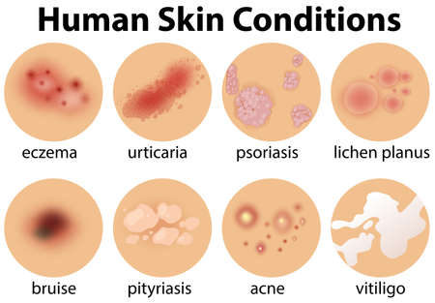

**Figure 1: Types of skin diseases**

* 1. **DEFINITION**

The largest organ of human body is “Skin”, an adult carry around 3.6 kg and 2 square meters of it. Skin acts as a waterproof, insulating shield, guarding the body against extremes of temperature, damaging UV lights, and harmful chemicals. With the rate of 10-12%, the population affected across India from skin disease is estimated at nearly 15.1 Crore in 2013 and which increases to 18.8 crores by 2015[38]. According to statistics provided by the World Health Organization [39] around 13 million melanoma skin cancer occurs globally each year, which shows skin diseases are growing very rapidly. There are many factors responsible for a disease to occur such as UV lights, pollution, poor immunity, and an unhealthy lifestyle. Skin diseases are conditions that affect your skin. These diseases may cause rashes, inflammation, itchiness or other skin changes. Skin disorders vary greatly in symptoms and severity. They can be temporary or permanent, and may be painless or painful. Some have situational causes, while others may be genetic. Some skin conditions are minor, and others can be life-threating. While most of skin disorders are minor other can indicate a more serious issue.

* **ACNE:**
  + Commonly located on the face, neck, shoulders, chest and upper back.
  + Breakouts on the skin composed of blackheads, whiteheads, pimples, or deep, painful cysts and nodules.
  + May leave scars or darken the skin if untreated.
* **MELANOMA:**
  + The most serious form of skin cancer, more common in fair_skinned people.
  + Mole anywhere on the body that has irregularly shaped edges, asymmetrical shape, and multiple colors.
  + Mole that has changed color or gotten bigger over time.
  + Usually larger than a pencil eraser.
* **PSORIASIS:**
  + Scaly, silvery, sharply defined skin patches.
  + Commonly located on the scalp, elbows, knees, and lower back.
  + May be itchy or asymptomatic.
  + Easy bleeding or oozing wound that doesn’t seem to heal, or heals and then reappears.
* **ROSACEA:**
  + Chronic skin disease that goes through cycles of fading and relapse.
  + Relapses may be triggered by spicy foods, alcoholic beverages, sunlight, stress, and the intestinal bacteria helicobacter pylori.
  + There are four subtypes of rosacea encompassing a wide variety of symptoms.
  + Common symptoms include facial flushing, raised, red bumps, facial redness, skin dryness, and skin sensitivity.
* **VITILIGO:**
  + Loss of pigment in the skin due to autoimmune destruction of the cells that give skin its color.
  + Focal pattern: Loss of skin color in only a few small areas that may merge together.
  + Segmental pattern: Depigmentation on one side of the body.
  + Premature graying of scalp and / or facial hair.
  1. **OBJECTIVE OF PROJECT:**

The skin disease diagnosis includes series of pathological laboratory tests for the identification of the correct disease. For the past ten years these diseases have been the matter of concern as their sudden arrival and their complexities have increased the life risks. These Skin abnormalities are very infectious and need to be treated at earlier stages to avoid it from spreading. Total wellbeing including physical and mental health is also affected adversely. Many of these skin abnormalities are very fatal particularly if not treated at an initial stage. Human mindset tends to presume that most skin abnormalities are not as fatal as described thereby applying their own curing methods. However if these remedies are not apt for that selective skin problem then it makes it even worse. The available diagnosis procedure consists of long laboratory procedures but here we  propose a system which will enable users to predict the skin disease using Convolutional Neural Network(CNN). The system consists of three phases- The feature extraction phase, the training phase and the testing /validation phase. The system makes use of deep learning technology to train itself with the various skin images. The main objective of this system is to achieve maximum accuracy of skin disease prediction.

* 1. **PURPOSE:**

The diagnosis and treatment of a skin disease takes longer time and causes financial and physical cost to the patient. In general, most of the common people do not know the type and stage of a skin disease. Some of the skin diseases show symptoms several months later, causing the disease to develop and grow further. This is due to the lack of medical knowledge in the public. Sometimes, a dermatologist (skin specialist doctor) may also find it difficult to diagnose the skin disease and may require expensive laboratory tests to correctly identify the type and stage of the skin disease. The advancement of lasers and photonics based medical technology has made it possible to diagnose the skin diseases much more quickly and accurately. But the cost of such diagnosis is still limited and very expensive.

1. **PROBLEM STATEMENT**

Now day’s skin diseases become more common problem in human life. Most of these diseases are dangerous and harmful, particularly if not treated at an initial stage. People do not treat skin diseases seriously. Sometimes, most of the people treat these infections of the skin using their own household methods. However, if these household treatments are not suitable for that particular skin problem then it would affect the skin. Also they may not be aware of severe problem of skin diseases. Skin diseases have tendency to pass from one person to another person easily. Hence it is very important to control it at earlier stage to prevent it from spreading in people. The damage done to the skin due to skin diseases also could damage the self-confidence, mental confidence as well as wellbeing of people. Therefore the skin diseases are become a huge problem among people. It has become an important thing to treat these skin diseases properly at the earlier stages itself to prevent serious damage to skin. This system would help to solve this problem to a great extent. Since it system would allow users to determine the skin diseases to provide treatments or advice to patient by making use of images of skin infected with the disease and by obtaining information from the patient.

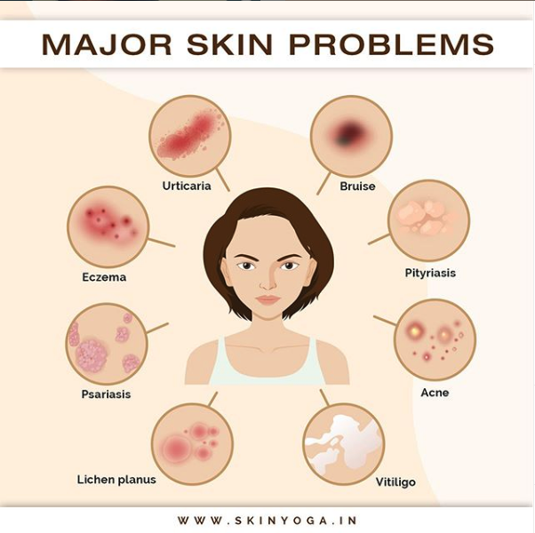

**Figure 2: Major skin diseases**

1. **LITERATURE SURVEY**
   1. **EXISTING SYSTEM**

Skin diseases are more common than other diseases. Skin diseases may be caused by fungal infection, bacteria, allergy, or viruses, etc. There are many techniques or methods developed in order to classify, identify and also to prevent the skin diseases. Such existing systems are mentioned below:

* An Image processing-based method to detect skin diseases. This method takes the digital image of disease effect skin area, then use image analysis to identify the type of disease. Our proposed approach is simple, fast and does not require expensive equipment other than a camera and a computer. The approach works on the inputs of a color image. Then resize the of the image to extract features using pretrained convolutional neural network. After that classified feature using Multiclass SVM with 65% accuracy. The objective of the SVM classifier is to find the hyper plane that separates the points of classes C1andC2 with a maximum margin, linearly penalizing points within the margin through a regularization parameter selected by the user. Support vector machines bring a new option to the pattern recognition problem with clear connections in statistical learning theory. They differ radically from other methods, for example, neural networks—the training of an SVM always finds a global minimum and its simple geometric interpretation provides much scope for deeper investigations.

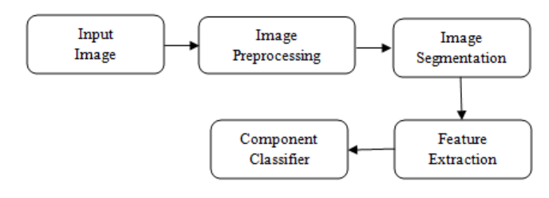

**Figure 3: Classification using SVM classifier**

* Image processing technique such as rgb to gray conversion of image, image resize and image filtering using median filter. Localized segmentation is used extract the required image. Using this process features of images is extracted which is useful to identify the diseases and find out the stages of diseases.

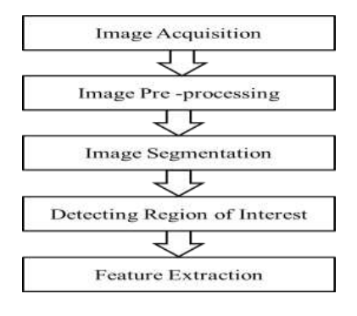

**Figure 4: Classification using Image processing**

* 1. **PROPOSED SOLUTION**

Skin diseases are the 4th common cause of skin burden worldwide. Robust and Automated system have been developed to lessen this burden and to help the patients to conduct the early assessment of the skin lesion. Mostly this system available in the literature only provides skin cancer classification. Treatments for skin are more effective and less disfiguring when found early and it is a challenging research due to similar characteristics of skin diseases. In this project we attempt to detect skin diseases.

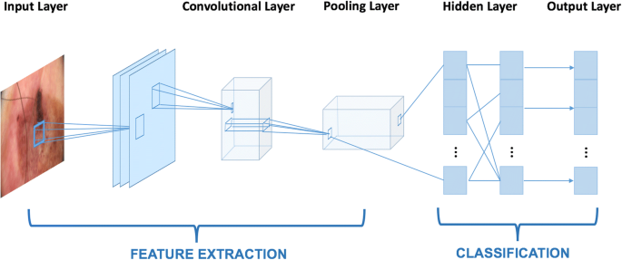

**Figure 5: Feature Extraction and Classification of different skin diseases**

The proposed approach is based on the pre-processing, Deep learning algorithm, training the model, validation and classification phase. Experiments were performed on various skin disease images and 93% accuracy is achieved for five-class classification using Convolution Neural Networks (CNN). CNNs are neural networks with a specific architecture that have been shown to be very powerful in areas such as image recognition and classification.

The architecture of a CNN has 3 main layers, the convolutional layer, pooling layer, and fully connected layer. The first layer calculates the output of neurons which are linked with local regions. Each one is calculated by a dot product of weights and the region. For image inputs, typical filters are small in area such as 3 × 3. A convolution layer is used for a matrix filter and to perform convolution operation to detect patterns in the image. The maxpooling2d layer is used for filtering and reducing the dimensionality of a featured map from 3 by 3 matrix to 2 by 2 matrix with some common conditions and evaluates the common patterns. Flatten layer is used to transform the 2 dimensional array from pooled featured map into a single dimensional long continuous vector.

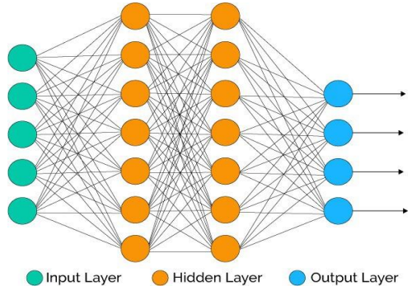

**Figure 6: Fully connected layer of CNN**

The output of flatten layer is carried to a fully connected layer which consists of input, hiden and output layers. For that purpose we are adding the dense layer to our model. Dense layer is a simple layer of neurons in which each neuron receives input from all the neurons of previous layer. Here two activation functions are used relu and sigmoid. Relu is the best activation function used for hidden layers and sigmoid activation function is used for classification purpose in the output layer. The activation function means it determines the output of node from the given input to the node.

Once layers have been added, we need to set up a score function, a loss function and a proper optimization algorithm. We define binary cross entropy as our loss function which will actually measure the error rate between the observed labels and predicted labels. Next most important is the optimizer. Adam Optimizer has advantage as it involves functions of other optimizers as well. Adam is a well known and popular algorithm in the field of learning models. Next is the metric function which is used to evaluate the performance of the system, metric accuracy is used.

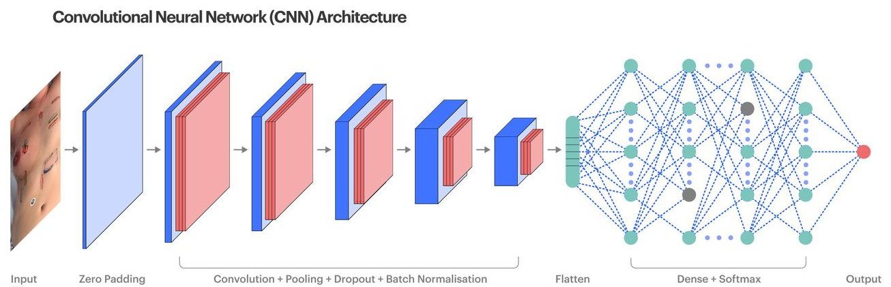

**Figure 7: Layers of CNN**

Finally can classify the skin diseases such as (Acne, Melanoma, Psoriasis, Rosacea, Vitiligo) with 93 % accuracy. “More the accuracy, better is the model”. Every model is evaluated based on the accuracy achieved and the loss obtained.

After prediction certain treatment for skin disorders is required:

* Antihistamines
* Medicated creams and ointments
* Antibiotics
* Vitamin or steroid injections
* Laser therapy
* Targeted prescription medications

Not all skin disorders respond to treatment. Some conditions go away without treatment. People with permanent skin conditions often go through periods of severe symptoms. Sometimes people are able to force incurable conditions into remission. However, most skin conditions reappear due to certain triggers, such as stress or illness.

You can often treat skin disorders that are temporary and cosmetic with:

* Medicated makeup
* Over-the-counter skin care products
* Good hygiene practices
* Small life style adjustments such as making certain dietary changes.

1. **EXPERIMENTAL ANALYSIS**

Skin types of diseases are most common among the globe, as people get skin disease due to inheritance, environmental factors. In many cases people ignore the impact of skin disease at the early stage. We propose a skin disease detection method based on image processing and deep learning techniques. The patient provides an image of the infected area of the skin as an input to the prototype. Image processing techniques are performed on this image and feature values are extracted and the classifier model predicts the disease. The proposed system is highly beneficial in rural areas where access to dermatologists is limited. The goal is to classify various images such as Acne, Melanoma, Psoriasis, Rosacea, Vitiligo.

* 1. **PROJECT ARCHITECTURE:**

The Project Architecture briefly explains the procedure involved:

* Firstly, Collect the dataset and split them into Training and Testing datasets.
* Preprocess both training and testing datasets.
* Use CNN to classify and build the model.
* Now using Python-Flask module and HTML build the app/webpage to classify the Disease.

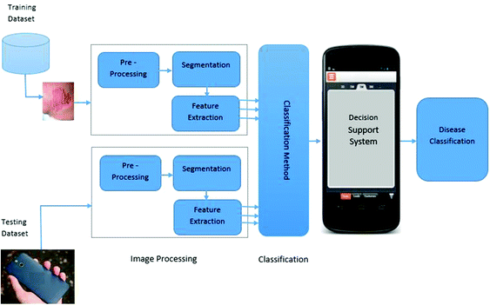

**Figure 8: Project Architecture**

* 1. **BLOCK DIAGRAM:**

Block diagram represents the procedure in systematic and sequential manner with its blocks connected by lines that show the relationship of the blocks.

* Initially, Labeled dermatoscopic images are collected.
* Preprocess the images.
* Training using Convolutional Neural Network.
* Using the CNN models build them.
* Classify them using CNN.
* Again prerprocess for selecting the images for prediction.
* Finally predict them in webpage

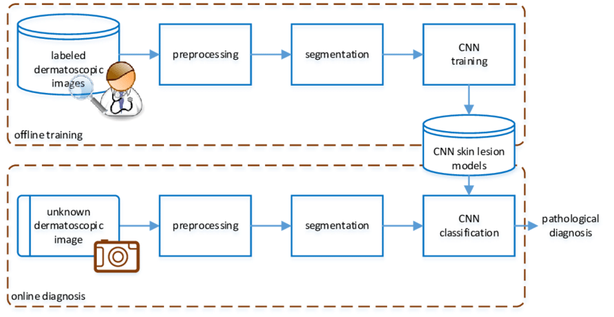

**Figure 9: Block diagram representing process of CNN**

* 1. **SOFTWARE REQUIREMENTS**
* Python 3.9:
* Python is an interpreted high-level general-purpose programming language.
* Python can be used on a server to create web applications.
* Visual Studio Code:
* Visual studio code is a source-coeditor made by Microsoft for Windows, linux and macOS.
* Features include support for debugging, syntax highlighting, intelligent code completion, snippets, code refactoring, and embedded Git.
* Anaconda Environment
* The default environment base (path) is used because it consists of multiple libraries and modules.
* Tensorflow and keras modules:
  + Tensorflow and keras is used for the purpose of CNN model building.
* Flask:
  + Flask is the module used for web framework.
  + Flask provides you with tools, libraries and technologies that allow you to build a web application.

  

**Figure 10: Logos of python and VSCode and the base environment location in Anaconda**

* 1. **PROJECT FLOW**

1. **Data Collection**
   1. In our project according to project structure, create train & test folders with 5 folders of skin diseases named Acne, Melanoma, Psoriasis, Rosacea, Vitiligo in each test and train folders.
2. **Image Preprocessing**
   1. Import image data generator library and configure it
   2. Apply image data generator functionality to train and test datasets

### Model Building

### Importing the required libraries for model building:

### Importing libraries such as keras and tensorflow for using the convolutional neural network.

* 1. Initialize the model:

Sequential is the model used for CNN, for that initializing the model is required.

* 1. Add convolution layer:

Convolution is the first layer to extract features from an input image. Convolution preserves the relationship between pixels by learning image features using small squares of input data.

* 1. Add max pooling layer:

Pooling layer is used for filtering the pixels size.

* 1. Add flatten layer:

Flatten layer is used for converting multidimensional array to single dimensional array.

* 1. Compile the model:

Compiling the model takes three parameters: optimizer, loss and metrics.

* 1. Fit and save the model:

To train, we will use the ‘fit()’ function on our model with the following parameters: training data, target data, and the number of epochs.

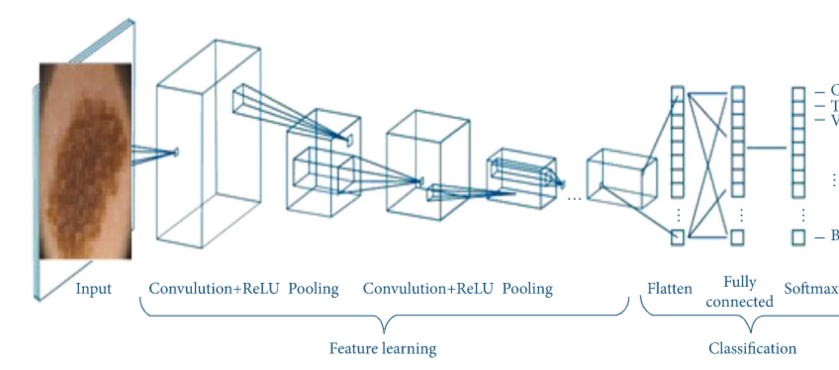

**Figure 11: Model Building**

### Test the Model

* 1. Import the saved model:

Import the model that is saved in a plain text file (.h5).

* 1. Load the test image, preprocess it and then predict and check for results:

Preprocessing the image and predicting the image which is required.

### Application Building

* 1. Build a FLASK application:

Flask provides you with tools, libraries and technologies that allow you to build a web application.

* 1. Build the HTML page and execute it:

HTML page is used for developing the webpage to display the result in webpage.

* 1. Run the app:

Run the python file such that the pages are rendered and linked to webpage’s with a local host.

1. **DESIGN**
   1. **CLASS DIAGRAM**

Class diagram is a static diagram. It represents the static view of an application. Class diagram is not only used for visualizing, describing, and documenting different aspects of a system but also for constructing executable code of the software application. Class diagram describes the attributes and operations of a class and also the constraints imposed on the system. The class diagrams are widely used in the modeling of object oriented systems because they are the only UML diagrams, which can be mapped directly with object-oriented languages. Class diagram shows a collection of classes, interfaces, associations, collaborations, and constraints. It is also known as a structural diagram.

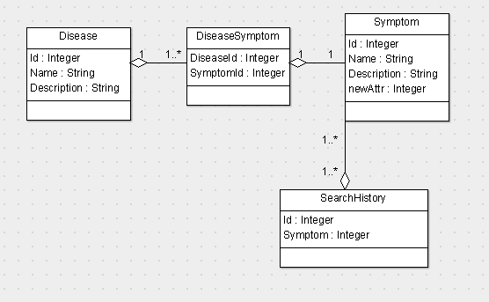

**Figure 12: Class diagram**

* 1. **USE CASE DIAGRAM**

A use case diagram is usually simple. It does not show the detail of the use cases:

* It only summarizes some of the relationships between use cases, actors, and systems.
* It does not show the order in which steps are performed to achieve the goals of each use case.

The use-case diagram corresponding to the project is depicted in Fig 7. There are two users:

* patient
* server

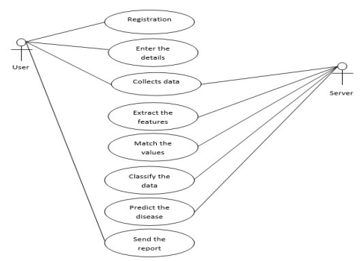

**Figure 13: Use Case Diagram**

* 1. **SEQUENCE DIAGRAM**

A **sequence diagram** or **system sequence diagram** (SSD) shows object interactions arranged in time sequence in the field of software engineering. It depicts the objects involved in the scenario and the sequence of messages exchanged between the objects needed to carry out the functionality of scenario.

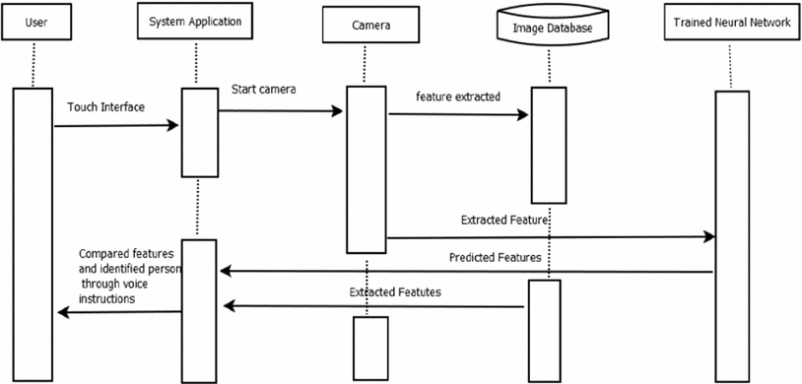

**Figure 14: Sequence Diagram**

* 1. **FLOWCHART**

A flowchart is a picture of the separate steps of a process in sequential order.

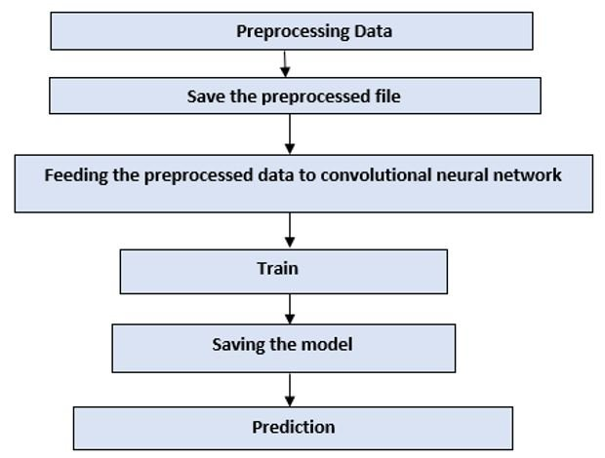

**Figure 15: Flowchart**

1. **CONCLUSION**

In UG Project Phase-1, we have worked on problem statement, literature survey and also done the experimental analyses which are required for the project to move forward. In experimental analysis we have discussed about the deep learning concepts and models and explained the algorithms to be used in the project. We also discussed about the flowcharts, use case diagrams, decision tree and sequence diagrams which are used in the project. Based on the experimental analysis we have designed the model for the project. Entire designing part is involved in UG Project Phase-1.

1. **FUTURE SCOPE**

UG Project Phase-2 is the extension of UG Project Phase-1. UG Project Phase-2 involves all the coding and implementation of the design which we have retrieved from UG Project Phase-1. All the implementation is done and conclusions will be retrieved in the phase. We will also work on the applications, advantages, and disadvantages of the project in this phase. Future scope of the project will be also discussed in the UG Project Phase-2.

**SKIN DISEASE IDENTIFICATION USING IMAGE ANALYSIS**

A UG Project Phase – II report submitted to

**JAWAHARLAL NEHRU TECHNOLOGICAL UNIVERSITY, HYDERABAD**

In partial fulfillment of the requirements for the award of the degree of

**BACHELOR OF TECHNOLOGY**

In

**COMPUTER SCIENCE AND ENGINEERING**

Submitted By

**THOUTI REDDY SUDEEPA 18UK1A05M4**

Under the guidance of

**Mr. A. ASHOK KUMAR**

Assistant Professor



**DEPARTMENT OF COMPUTER SCIENCE AND ENGINEERING**

**VAAGDEVI ENGINEERING COLLEGE**

Affiliated to JNTUH, HYDERABAD

BOLLIKUNTA, WARANGAL (T.S) – 506005

**DEPARTMENT OF COMPUTER SCIENCE AND ENGINEERING**

**VAAGDEVI ENGINEERING COLLEGE**

**WARANGAL**



**CERTIFICATE OF COMPLETION**

**UG PROJECT PHASE-II**

This is to certify that the UG Project Phase – II report entitled **"SKIN DISEASE IDENTIFICATION USING IMAGE ANALYSIS”** is being submitted by **T. SUDEEPA REDDY (18UK1A05M4)** in partial fulfillment of the requirements for the award of the degree of Bachelor of Technology in Computer Science & Engineering to Jawaharlal Nehru Technological University Hyderabad during the academic year 2021- 2022.

**Project Guide HOD**

**Mr. A. ASHOK KUMAR Dr. R. NAVEEN KUMAR**

(Assistant Professor) (Professor)

**EXTERNAL**

**ACKNOWLEDGEMENT**

We wish to take this opportunity to express our sincere gratitude and deep sense of respect to our beloved **Dr. P. Prasad Rao**, Principal, Vaagdevi Engineering College for making us available all the required assistance and for his support and inspiration to carry out this UG Project Phase – II in the institute.

We extend our heartfelt thanks to **Dr. R. Naveen Kumar**, Head of the Department of CSE, Vaagdevi Engineering College for providing us necessary infrastructure and thereby giving us freedom to carry out the UG Project Phase – II.

We express heartfelt thanks to the Major Project Coordinator, **Dr. J. Aruna kranthi**, Assistant Professor, Department of CSE for his constant support and giving necessary guidance for completion of this UG Project Phase – II.

We express heartfelt thanks to the guide, **Mr. A. Ashok Kumar**, Assistant Professor, Department of CSE for his constant support and giving necessary guidance for completion of this UG Project Phase – II.

Finally, we express our sincere thanks and gratitude to our family members, friends for their encouragement and outpouring their knowledge and experiencing throughout thesis.

**TABLE OF CONTENTS**

**LIST OF FIGURES**

**LIST OF CHAPTERS PAGE NO**

### INTRODUCTION 1

### CODE SNIPPETS 3

### MODEL.CODE 3

### HTML CODE 7

### APP1.PY CODE 9

### CONCLUSION 10

### APPLICATION 16

### ADVANTAGES 17

### DIS-ADVANTAGES 17

### FUTURE SCOPE 18

### REFERENCES 18

### HELP FILE 19

# LIST OF FIGURES PAGE NO:

Figure 1: Describing the steps involves and importing libraries 3

Figure 2: Creating train and test folders consisting dataset directories and building the

sequential model 3

Figure 3: Adding the layers to the model 4

Figure 4: Compiling and Fitting the model 4

Figure 5: Number of epochs run with its loss and accuracy Saving the model into .h5 file 5

Figure 6: Loading the model and image into respective variables 5

Figure 7: Converting the floating data type to integer 6

Figure 8: Converting array to string 6

Figure 9: With the help of index list of diseases names, predicting the type of disease 7

Figure 10: Html code with head tag consists title and background image of webpage 7

Figure 11: Html code describing body tag which consists the content of webpage 8

Figure 12: Html code which displays the predicted image of the disease type 8

Figure 13: Importing python libraries including flask and initializing flask 9

Figure 14: Code that helps to predict the disease and returns the message to html 9

Figure 15: Initial screen of webpage which is asking to choose an image 10

Figure 16: Uploaded an image of person which is predicted as ACNE 11

Figure 17: Uploaded an image of person which is predicted as MELANOMA 12

Figure 18: Uploaded an image of person which is predicted as PSORIASIS 13

Figure 19: Uploaded an image of person which is predicted as ROSACEA 14

Figure 20: Uploaded an image of person which is predicted as VITILIGO 15

1. **INTRODUCTION**

Skin diseases are conditions that affect your skin. These diseases may cause rashes, inflammation, itchiness or other skin changes. Some skin conditions may be genetic, while lifestyle factors may cause others. Skin disease treatment may include medications, creams or ointments, or lifestyle changes.

Your skin is the large organ that covers and protects your body. Your skin has many functions. It works to:

* Hold in fluid and prevent [dehydration](https://my.clevelandclinic.org/health/treatments/9013-dehydration).
* Help you feel sensations, such as temperature or pain.
* Keep out bacteria, viruses and other causes of infection.
* Stabilize your body temperature.
* Synthesize (create) vitamin D in response to sun exposure.

Skin diseases include all conditions that clog, irritate or inflame your skin. Often, skin diseases cause [rashes](https://my.clevelandclinic.org/health/diseases/17413-rashes-red-skin) or other changes in your skin’s appearance.

A convolution neural network (CNN) method is proposed in this study to boost the automatic identification of breast cancer by analyzing the Histopathological images. CNNs are applied to explore patterns in an image. CNNs are very effective at detecting objects in images. The proposed system uses CNNs to detect breast cancer from breast tissue images. The architecture of a CNN has 3 main layers, the convolutional layer, pooling layer, and fully connected layer. The first layer calculates the output of neurons which are linked with local regions. Each one is calculated by a dot product of weights and the region.

For image inputs, typical filters are small in area such as 3 × 3. Pooling layer uses multiple filters to detect specific patterns which are in common. Pooling layer reduces number of parameters and dimensionality. Flatten layer is the process of converting all resultant 2 dimensional arrays from pooled featured map to a single long continuous linear vector. Further this flattened matrix from flatten layer is fed as input to fully connected layer to classify the image. After Classifying the image the further prediction is done in webpage by uploading an histopathology image which is trained previously in Convolutional Neural Network.

UG Project Phase-2 involves all the coding and implementation of the design which we have retrieved from UG Project Phase-1. All the implementation is done and conclusions are retrieved in this phase. We will also work on the applications, advantages, and disadvantages of the project in this phase. Future scope of the project will be also discussed in the UG Project Phase-2.

1. **CODE SNIPPETS**

### MODEL CODE

### DISEASE_CNN.IPYNB CODE:

### 

### Figure 1: Describing the steps involves and importing libraries

### 

### Figure 2: Creating train and test folders consisting dataset directories and building the sequential model

### 

### Figure 3: Adding the layers to the model

### 

### Figure 4: Compiling and Fitting the model

### 

### Figure 5: Number of epochs run with its loss and accuracy. Saving the model into .h5 file

### DISEASE_PREDICTION.IPYNB CODE:

### 

### Figure 6: Loading the model and image into respective variables

### 

### Figure 7: Converting the floating data type to integer

### 

### Figure 8: Converting array to string

### 

### Figure 9: With the help of index list of diseases names, predicting the type of disease

### HTML CODE

### BASE.HTML:

### 

### Figure 10: Html code with head tag consists title and background image of webpage

### 

### Figure 11: Html code describing body tag which consists the content of webpage

### 

### Figure 12: Html code which displays the predicted image of the disease type.

### PYTHON CODE

### APP1.PY CODE:

### 

### Figure 13: Importing python libraries including flask and initializing flask

### 

### Figure 14: Code that helps to predict the disease and returns the message to html

### CONCLUSION

The following steps listed above are performed by our team, and herewith we attach snaps of our web page we achieved.

* The URL 127.0.0.1.5000 renders to display this webpage.
* First division of the webpage displays the “Skin Disease Recognition Using CNN” with two different colors red and black.
* Next division consists of “Skin Disease Recognition” heading and the content which describes about the Skin Disease.
* The message “Please Upload a skin disease image” is requesting to upload an image.
* “Choose” button is used which helps for choosing the image from the uploads.
* We can see a background image to make the page more efficient.

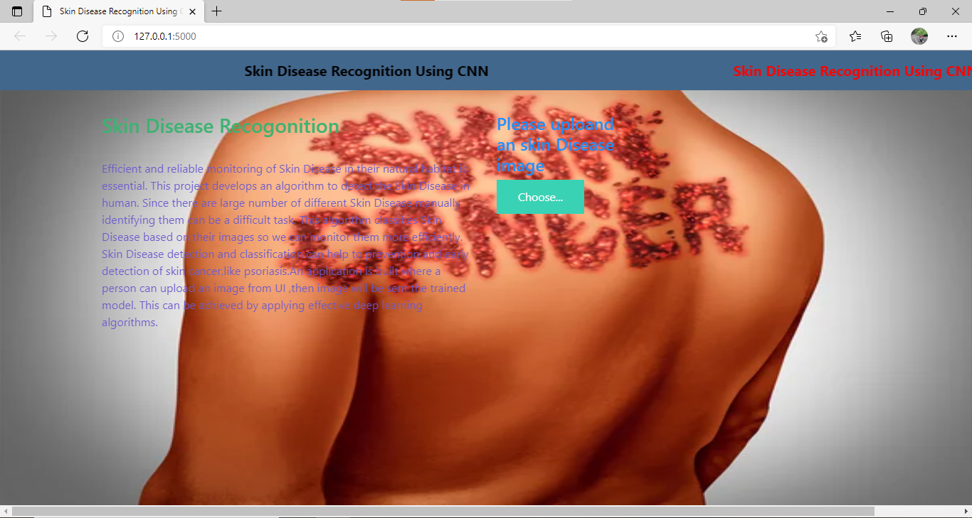

**Figure 15: Initial screen of webpage which is asking to choose an image**

* 1. **ACNE DISEASE:**

Acne is a very common skin condition that causes pimples mostly on the face, forehead, chest, shoulders and upper back. There are a variety of causes including genetics, fluctuating hormone levels, stress, high humidity and using oily or greasy personal care products. Acne commonly affects teenagers but can occur at any age.

**Types of acne:**

* **Blackheads:** Open bumps on the skin that fill with excess oil and dead skin. They look as if dirt has deposited in the bump, but the dark spots are actually caused by an irregular light reflection off the clogged follicle.
* **Whiteheads:** Bumps that remain closed by oil and dead skin.
* **Papules:** Small red or pink bumps that become inflamed.
* **Pustules:** Pimples containing pus. They look like whiteheads surrounded by red rings. They can cause scarring if picked or scratched.
* **Fungal acne (pityrosporum folliculitis):**This type occurs when an excess of yeast develops in the hair follicles. They can become itchy and inflamed.
* **Nodules:** Solid pimples that are deep in your skin. They are large and painful.
* **Cysts:** Pus-filled pimples. These can cause scars.

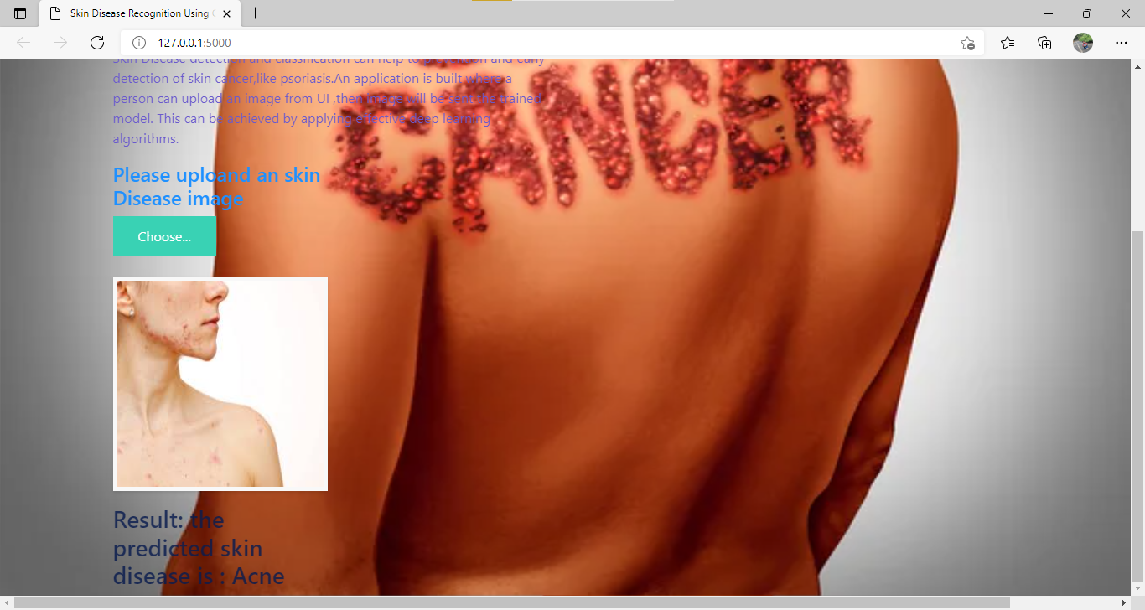**Figure 16: Uploaded an image of person which is predicted as ACNE**

* 1. **MELANOMA DISEASE:**

Melanoma is the most invasive skin cancer with the highest risk of death. While it’s a serious skin cancer, it's highly curable if caught early. Prevention and early treatment are critical, especially if you have fair skin, blonde or red hair and blue eyes. Melanoma comes from skin cells called melanocytes. These cells produce melanin, the dark pigment that gives skin its color. Most melanomas are black or brown in color, but some are pink, red, purple or skin-colored. Melanoma can appear as moles, scaly patches, open sores or raised bumps. Use the American Academy of Dermatology's "ABCDE" memory device to learn the warning signs that a spot on your skin may be melanoma:

* **A**symmetry: One half does not match the other half.
* **B**order: The edges are not smooth.
* **C**olor: The color is mottled and uneven, with shades of brown, black, gray, red or white.
* **D**iameter: The spot is greater than the tip of a pencil eraser (6.0 mm).
* **E**volving: The spot is new or changing in size, shape or color.

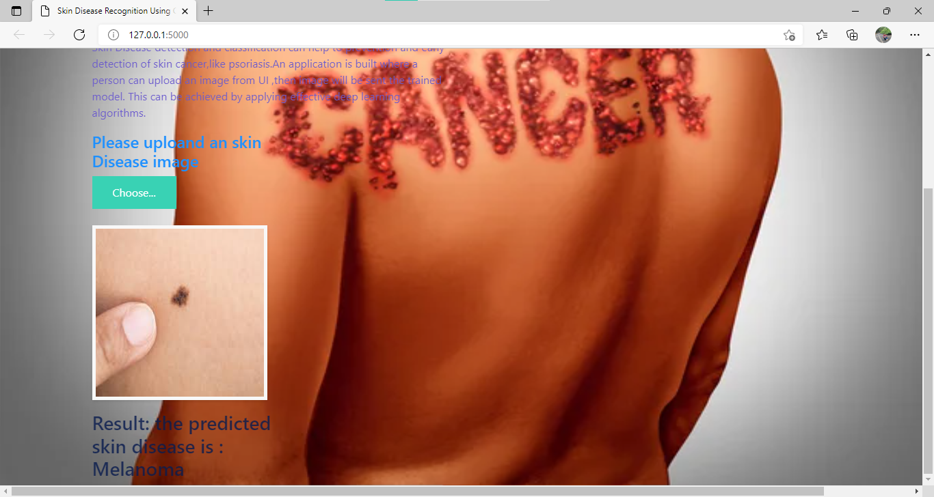

**Figure 17: Uploaded an image of person which is predicted as MELANOMA**

* 1. **PSORIASIS DISEASE:**

Psoriasis, a skin disorder, may cause itchiness and discomfort. Plaque psoriasis, the most common type, causes thick, scaly patches of skin. While there is no cure, psoriasis treatment can keep symptoms under control. Your provider may prescribe special creams or shampoos for psoriasis. Psoriasis usually starts in early adulthood, though it can begin later in life. People of any age, gender or race can get psoriasis. It can get better and worse throughout your life.

Types of psoriasis:

* **Inverse psoriasis** appears in skin folds. It may look like thin pink plaques without scale.
* **Guttate psoriasis** may appear after a [sore throat](https://my.clevelandclinic.org/health/symptoms/8274-sore-throat-pharyngitis) caused by a [streptococcal infection](https://my.clevelandclinic.org/health/articles/5911-group-a-streptococcal-infections). It looks like small, red, drop-shaped scaly spots in children and young adults.
* **Pustular psoriasis** has small, pus-filled bumps on top of the red patches or plaques.
* **Sebopsoriasis** typically appears on the face and scalp as red bumps and plaques with greasy yellow scale. This type is a cross between psoriasis and [seborrheic dermatitis](https://my.clevelandclinic.org/health/diseases/14403-seborrheic-dermatitis).

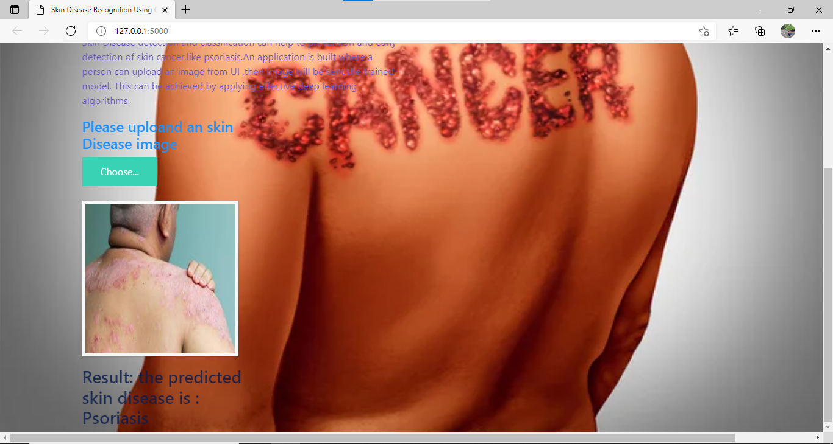

**Figure 18: Uploaded an image of person which is predicted as PSORIASIS**

* 1. **ROSACEA DISEASE:**

Rosacea is a common disorder — mainly affecting the facial skin — that causes redness on the nose, chin, cheeks and forehead. There are about 14 million people in the United States with the condition. It causes redness on the nose, chin, cheeks and forehead. Over time, the redness may become more intense, taking on a ruddy appearance. Small blood vessels may become visible.

In some cases, rosacea can appear on the chest, ears, neck or scalp. If rosacea is not treated, red solid bumps and pus-filled [pimples](https://my.clevelandclinic.org/health/articles/acne-overview) can develop. The disorder can cause the nose to take on a bulbous, swollen appearance called rhinophyma. Rosacea can affect the eyes, causing them to feel irritated and to appear bloodshot or watery. Styes may occur. This is called ocular rosacea.

* **Flushing:**Many people who have rosacea have a history of frequent blushing or flushing. The facial redness, which might come and go, often is the earliest sign of the disorder.
* **Persistent redness:**Persistent facial redness might resemble a blush or sunburn that does not go away.
* **Bumps and pimples:**Small red solid bumps or pus-filled pimples often develop. Sometimes the bumps might resemble acne, but blackheads are absent. Burning or stinging might be present.
* **Visible blood vessels:**Small blood vessels become visible on the skin of many people who have rosacea.

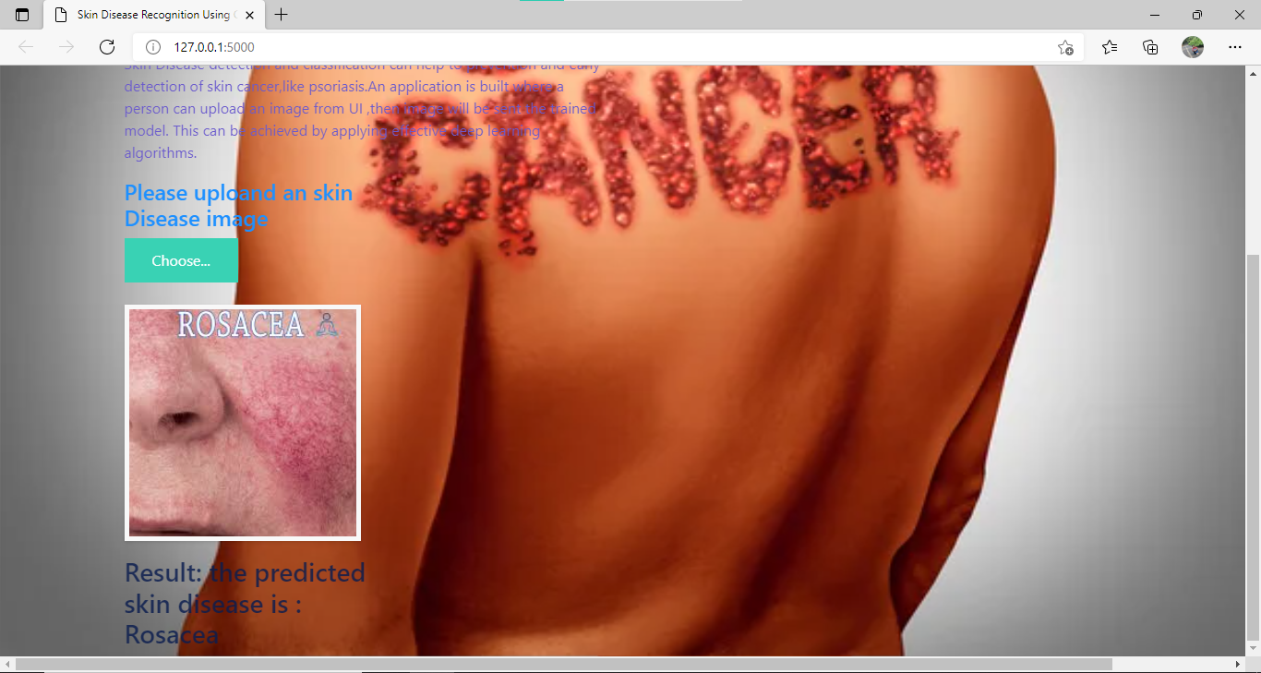

**Figure 19: Uploaded an image of person which is predicted as ROSACEA**

* 1. **VITILIGO DISEASE:**

Vitiligo is a skin disorder in which smooth white areas (called macules or patches) appear on a person’s skin. It generally starts on the hands, forearms, feet and face. Globally, about 1% or so of the population has vitiligo. Smooth white areas appear on a person’s skin. If you have vitiligo in a place that has hair, the hair on your body may also turn white. The condition occurs when melanocytes are destroyed by the body’s immune system.

Types of Vitiligo:

* **Generalized,** which is the most common type, when macules appear in various places on the body.
* **Segmental***,* which is restricted to one side of the body or one area, such as the hands or face.
* **Mucosal,**which affects mucous membranes of the mouth and/or the genitals.
* **Focal,**which is a rare type in which the macules are in a small area and do not spread in a certain pattern within one to two years.
* **Trichome,** which means that there is a white or colorless center, then an area of lighter pigmentation, and then an area of normally colored skin.
* **Universal**, another rare type of vitiligo, and one in which more than 80% of the skin of the body lacks pigment.

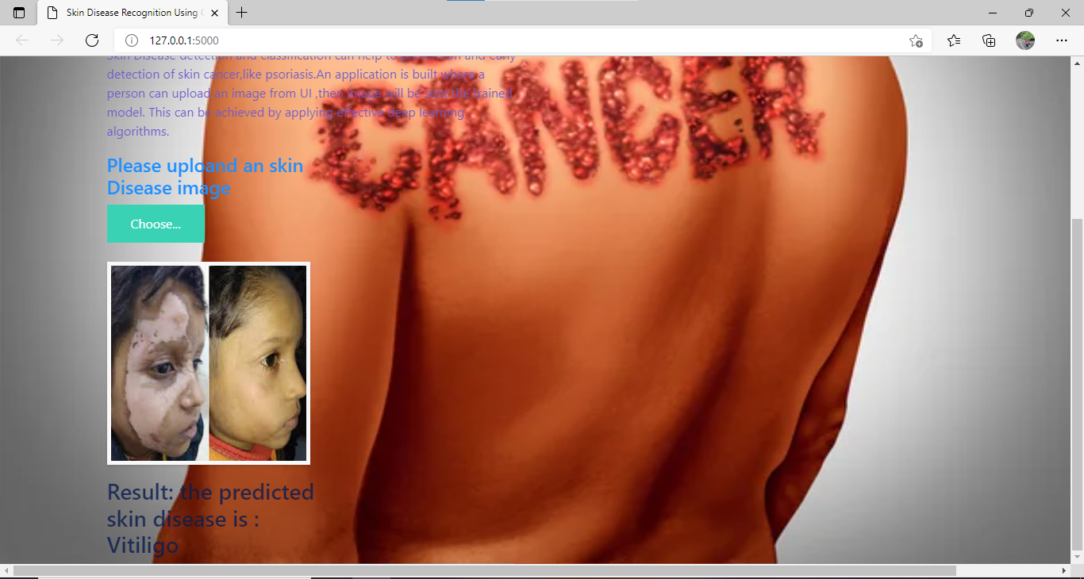

**Figure 20: Uploaded an image of person which is predicted as VITILIGO**

1. **APPLICATION**

The following application could be used in a better understanding with

* It is used by the people having busy schedule and cannot visit hospital at starting period of skin disease.
* It is used by the people to pre-confirm the type of diseases.
* As it reduces the cost, if a person has any money problem these can manage by this.
* If a person unable to consult doctor or come out of house (like covid-19)
* If patients past history details are also uploaded, and the accuracy can be increased if the system is fed to a large number of variety of dataset.
* With various technologies and AI(artificial intelligence) applications coming up in the near future we can add a lot of advantage to the current system and get more realistic results.
* We can also apply a series of techniques involving scanned images as well as other related data points together for the classification of the dataset.
* Artificial Intelligence (AI) techniques could also be used to understand the different regions of the human body during classification.

1. **ADVANTAGES**

* Acute prediction of diseases available first on hand to every citizen who uses this application,
* Disease Analysis possible right from home, sparing the need to visit Hospitals Nursing homes or health centres.
* Statistics on intensity, severity of the disease, past records and present records of others affected by similar disease presented in user interactive formats.
* The system also makes use of geo-location access, through which it becomes easy to identify whether a particular disease has become epidemic with respect to that particular location Awareness, Suggestions and first aid tips for every disease for quick user reference.
* Diseases, when identified quicker can be averted or cured much easier. Eases the jobs for Government Healthcare bodies, Corporation Health officials etc.
* Helps in medical department such as in laboratories for predicting the type of disease.
* By the reports we can analyze the stage of disorder that patient is suffering from.

1. **DIS-ADVANTAGES**

* Needs more than a single image for the prediction.
* They use to need a lot of training data.
* Need to upload new skin diseases datasets frequently
* Cannot predict images such as CT scan, x-rays, etc.
* If any images other than training images are given then it automatically prints the default prediction that has been predicted previously.

1. **FUTURE SCOPE**

* A common model should be adopted for the identification of all types of skin diseases
* Support for multilingualism to develop user-friendliness
* To expand the multiplatform capability through an introduction to IOS compatibility
* Here we used skin disease names in prediction but in future we can use another types such as benign or malignant types of skin disease.

1. **REFERENCES**

* [**https://www.irjet.net/archives/V7/i3/IRJET-V7I3265.pdf**](https://www.irjet.net/archives/V7/i3/IRJET-V7I3265.pdf)
* [**https://www.researchgate.net/publication/338759556_A_Method_Of_Skin_Disease_Detection_Using_Image_Processing_And_Machine_Learning**](https://www.researchgate.net/publication/338759556_A_Method_Of_Skin_Disease_Detection_Using_Image_Processing_And_Machine_Learning)
* [**https://ejmcm.com/article_2063_f2d63a2c4d81a4a58e8a25b20779c770.pdf**](https://ejmcm.com/article_2063_f2d63a2c4d81a4a58e8a25b20779c770.pdf)
* [**https://arxiv.org/ftp/arxiv/papers/1911/1911.07929.pdf**](https://arxiv.org/ftp/arxiv/papers/1911/1911.07929.pdf)

**9. HELP FILE**

**PROJECT EXECUTION:**

**STEP-1:** Go to **Start** in the Taskbar, search and launch **VISUAL STUDIO CODE.**

**STEP-2:** After launching **VISUAL STUDIO CODE, Open** the **existing folder** which consists of our project files.

**STEP -3: Open** the **.IPYNB** extension files (**DISEASE_CNN.IPYNB, DISEASE_PREDICTION.IPYNB** )

**STEP-4:** In the **DISEASE_CNN.IPYNB** model file run all the cells which will train the model for accurate results.

**STEP-5:** A **.h5** file will be generated which consists of the CNN model that is trained.

**STEP-6:**  In the **DISEASE_PREDICTION.IPYNB** model file will predict the skin diseases by running all the cells.

**STEP-7:** Create a Folder named **FLASK APPLICATION** on the project folder. Copy the .h5 file into this Flask Folder.

**STEP-8:** Extract all the **HTML, CSS** files and **python file(app.py)** into the **FLASK** **APPLICATION** folder.

**STEP-9:** Then go back to the **VISUAL STUDIO CODE** and open all the python, html files present in the **FLASK FOLDER.**

**STEP-10:** Open the Terminal in the **VISUAL STUDIO CODE** and open with the **Base Environment** which is used from **ANACONDA NAVIGATOR.**

**STEP-11:** After using the base environment in the terminal, follow the steps as shown in below:

cd File Path - > click enter

python app.py - > click enter (We could see running of files)

**STEP-12**: Then open BROWSER, at the URL area type ―**localhost:8000**”.

**STEP-13**: Home page of the project will be displayed.

**STEP-14:** Select the image by pressing the button “**Please Upload A Skin Disease Image**” that you wanted to predict and click on the “**PREDICT”** button.

**STEP-15:** Output will be generated whether which type of skin disease is the person suffering from.